ECA5403-ELECTROMAGNETIC FILEDS AND WAVES
C02-3
EXPERIMENT 8
Implementation of Dielectric Free-Space Boundary Conditions in Electric Field and Determination of Relative Permittivity
Aim
To implement the dielectric–free-space boundary conditions for electric fields and determine the relative permittivity of an unknown medium.
Test Case (i) – Normal and Tangential Field Components at the Free-Space / Dielectric Interface.
MATLAB Program:
clc; clear;
epsilon0 = 8.854e-12;
E1 = input('Enter magnitude of E1 in free space (V/m): ');
th1 = input('Enter angle of E1 with the normal (deg): ');
er2 = input('Enter relative permittivity of medium 2: ');
E1n = E1*cosd(th1); % normal component in medium 1
E1t = E1*sind(th1); % tangential component in medium 1
D1n = epsilon0*E1n; % normal flux density in medium 1
E2t = E1t; % tangential E is continuous
D2n = D1n; % normal D is continuous (rho_s = 0)
E2n = D2n/(epsilon0*er2); % normal E in medium 2
E2 = sqrt(E2n^2 + E2t^2);
th2 = atand(E2t/E2n);
fprintf('E1n = %.2f V/m, E1t = %.2f V/m\n', E1n, E1t);
fprintf('D1n = %.4e C/m^2\n', D1n);
fprintf('E2t = %.2f V/m, D2n = %.4e C/m^2\n', E2t, D2n);
fprintf('E2n = %.2f V/m, |E2| = %.2f V/m\n', E2n, E2);
fprintf('Refraction angle theta2 = %.2f deg\n', th2);
figure; plot([0 0],[-80 80],'k','LineWidth',2); hold on;
quiver(-E1n,-E1t,E1n,E1t,0,'b','LineWidth',2);
quiver(0,0,E2n,E2t,0,'r','LineWidth',2);
axis equal; grid on;
xlabel('Normal direction (V/m)'); ylabel('Tangential direction (V/m)');
title('Electric field at a free-space / dielectric interface');
OUTPUT:
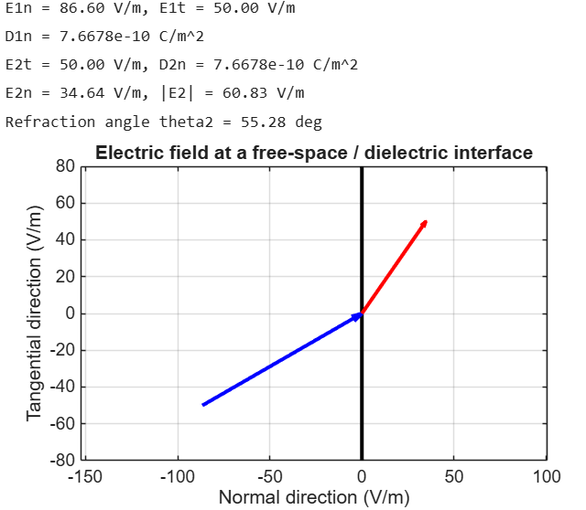
Test Case (ii) – Determination of the Unknown Relative Permittivity from Boundary-Field Data
MATLAB Program:
clc;
clear;
E1n = input('Enter normal E-field in free space E1n (V/m): ');
E2n = input('Enter measured normal E-field in the dielectric E2n (V/m): ');
er_ref = input('Enter reference relative permittivity: ');
er_calc = E1n/E2n; % from D1n = D2n: epsilon0*E1n = epsilon0*er*E2n ;
dev = abs(er_calc - er_ref)/abs(er_ref)*100;
fprintf('Calculated relative permittivity = %.4f\n', er_calc);
fprintf('Percentage deviation = %.2f %%\n', dev);
OUTPUT:
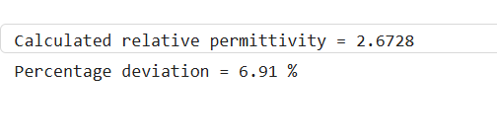
Test Case (iii) – Variation of the Refraction Angle with the Angle of Incidence for Different Dielectrics
Simulate the interface for three dielectric constants and plot the angle of the electric field in medium 2 against its angle in medium 1.
MATLAB Program:
clc; clear;
th1 = linspace(0,89,179);
er = [1.5 2.5 4];
figure; hold on;
for k = 1:3
th2 = atand(er(k)*tand(th1)); % tan(th2) = er2*tan(th1)
plot(th1,th2,'LineWidth',2);
end
plot(th1,th1,'k--'); % er2 = 1 (no dielectric)
grid on;
xlabel('Angle in medium 1, \theta_1 (deg)');
ylabel('Angle in medium 2, \theta_2 (deg)');
legend('er2 = 1.5','er2 = 2.5','er2 = 4','er2 = 1','Location','southeast');
title('Refraction of the electric field at the interface');

OUTPUT:

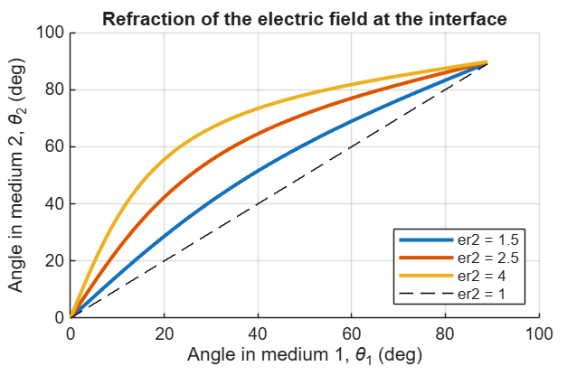
Test Case (iv) – Effect of the Relative Permittivity on the Field Components in the Dielectric
Keep the incident field fixed and vary εr2 to show which components are continuous across the boundary.
MATLAB Program:
clc;
clear;
epsilon0 = 8.854e-12;
E1 = 100; th1 = 30;
E1n = E1*cosd(th1); E1t = E1*sind(th1);
er2 = linspace(1,6,100);
E2n = E1n./er2; % normal E in medium 2
E2t = E1t*ones(size(er2)); % tangential E (continuous)
E2 = sqrt(E2n.^2 + E2t.^2);
D2n = epsilon0*er2.*E2n; % normal D (continuous)
subplot(1,2,1);
plot(er2,E2n,er2,E2t,er2,E2,'LineWidth',2); grid on;
xlabel('Relative permittivity er2'); ylabel('Electric field (V/m)');
legend('E2n','E2t','|E2|');
subplot(1,2,2);
plot(er2,D2n,'LineWidth',2); grid on; ylim([0 1e-9]);
xlabel('Relative permittivity er2'); ylabel('D2n (C/m^2)');

OUTPUT:
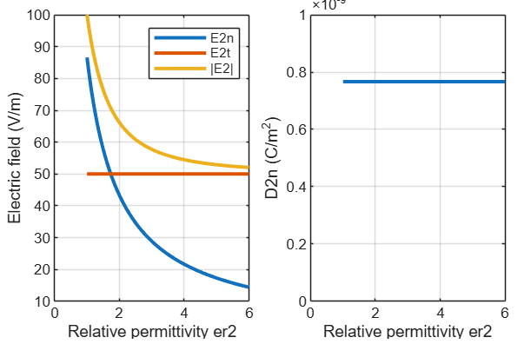

Objective | Assessment Criterion | Excellent – 4 | Good – 3 | Satisfactory – 2 | Needs Improvement – 1 | Weighting | Marks given | Marks obtained
Define interface and field components | Define interface and field components | Correctly identifies media, normal/tangential directions and surface-charge assumptions. | Setup is correct with minor omissions. | Needs guidance on components or assumptions. | Interface or component definitions are incorrect. | 25 | 2.5
Apply electric boundary equations | Apply electric boundary equations | Correctly applies continuity of tangential E and the normal D boundary relation. | Applies relations correctly with minor errors. | Partly correct application requires support. | Boundary relations are misapplied. | 25 | 2.5
Determine permittivity and validate | Determine permittivity and validate | Calculates relative permittivity/field components consistently and checks boundary conditions. | Results are mostly correct with minor discrepancies. | Validation is incomplete or contains errors. | Cannot obtain or validate valid results. | 30 | 3.0
Interpret and document results | Interpret and document results | Explains field behaviour across the interface and reports units/assumptions clearly. | Explanation is correct with minor omissions. | Explanation or documentation is incomplete. | Results are not interpreted correctly. | 20 | 2.0
TOTAL |  |  |  |  |  | 100 | 10

